SR UNIVERSITY
AI CODING
ASSIGNMENT NO : 3
NAME CHALLA.THANUSREE
ENROLLMENT NO :2403a54109
BATCH NO :04
3.1:
- PROMPT: Ask AI to write a function to calculate compound interest, starting with only the function name. Then add a docstring, then input-output example
Expected Output#1
- Comparison of AI-generated code styles7
CODE:
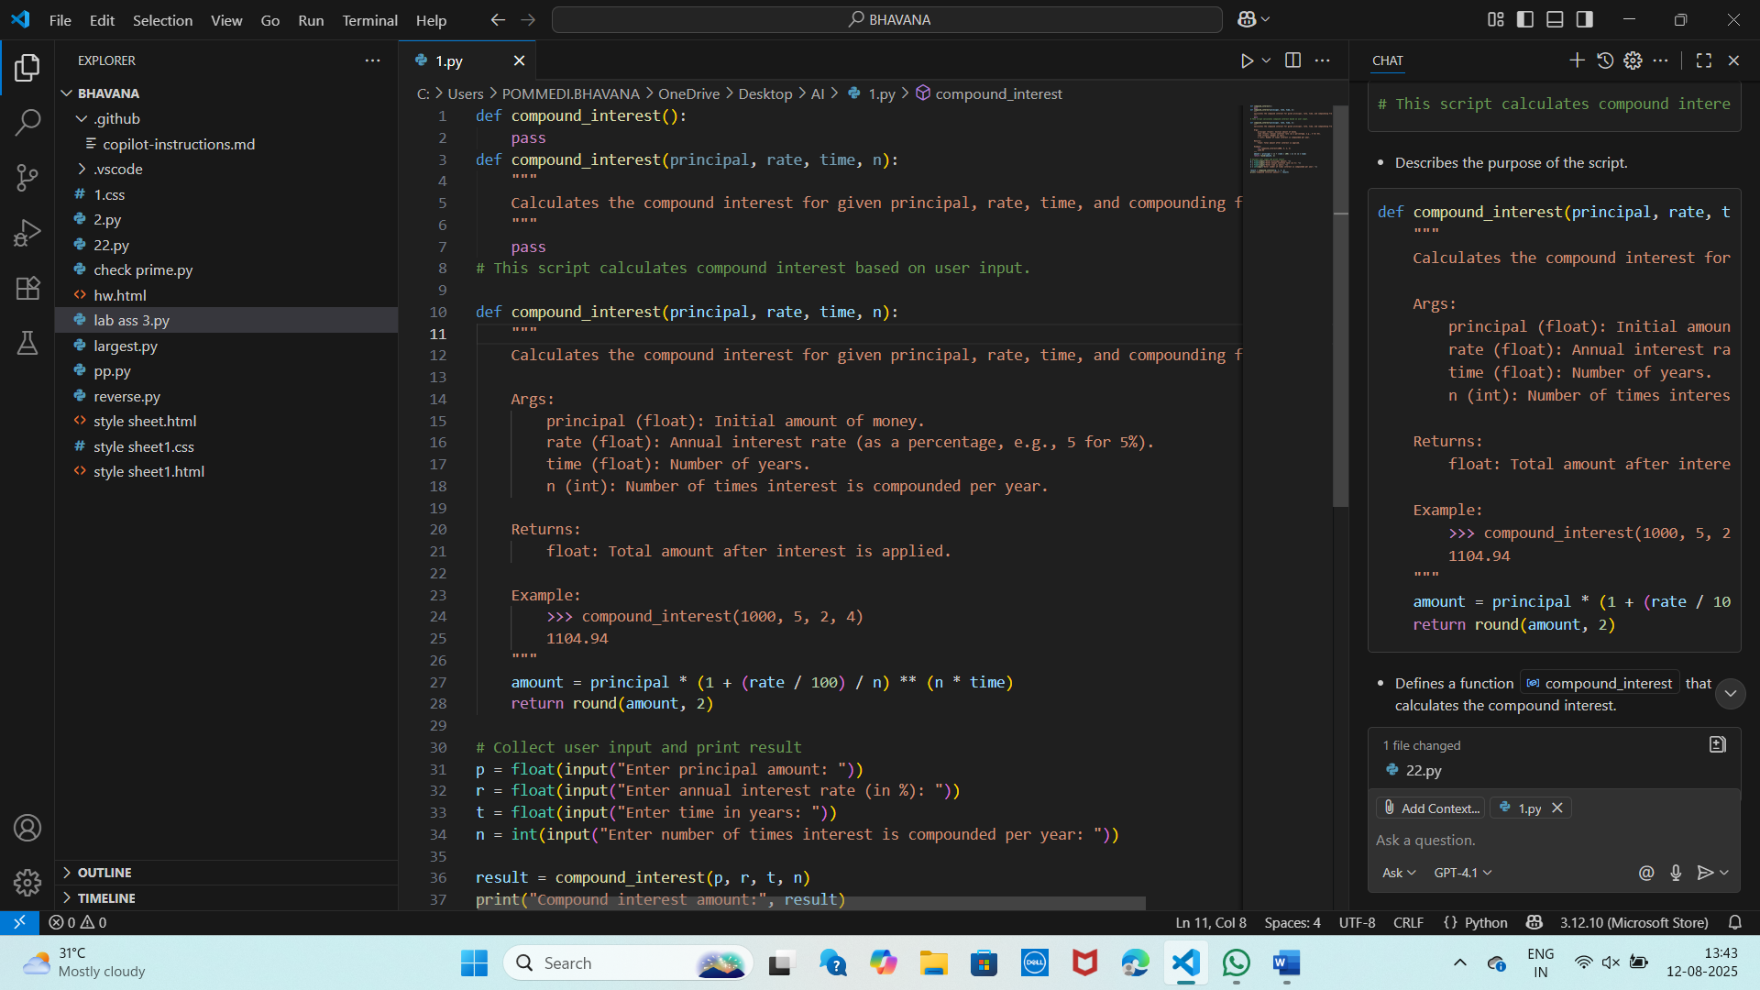
OUTPUT:
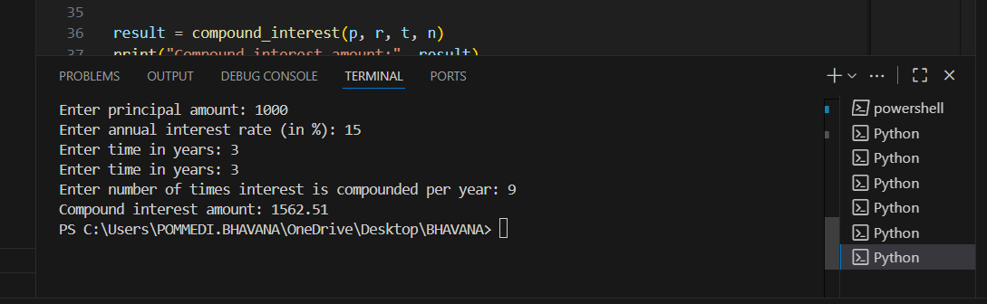
EXPLANATION:
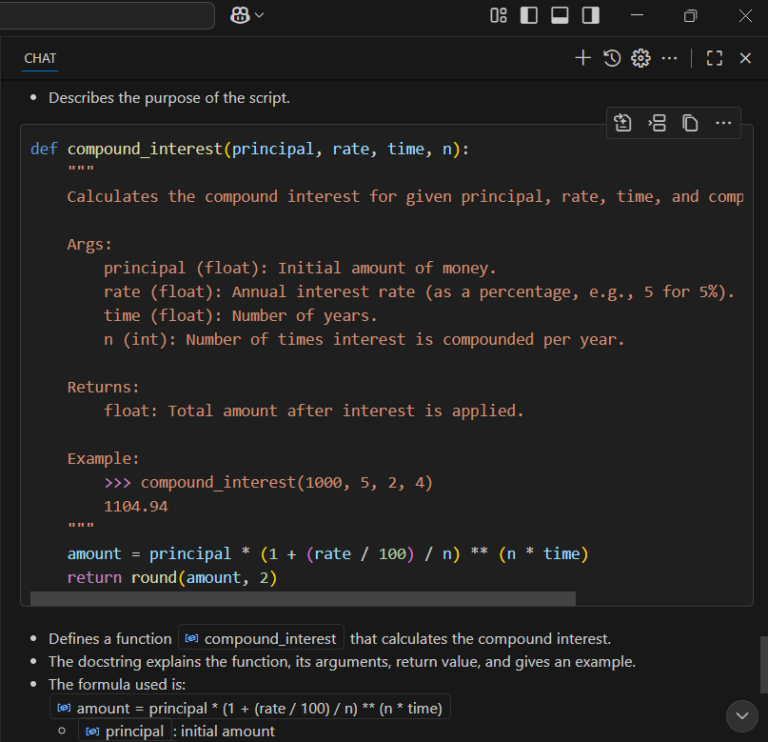
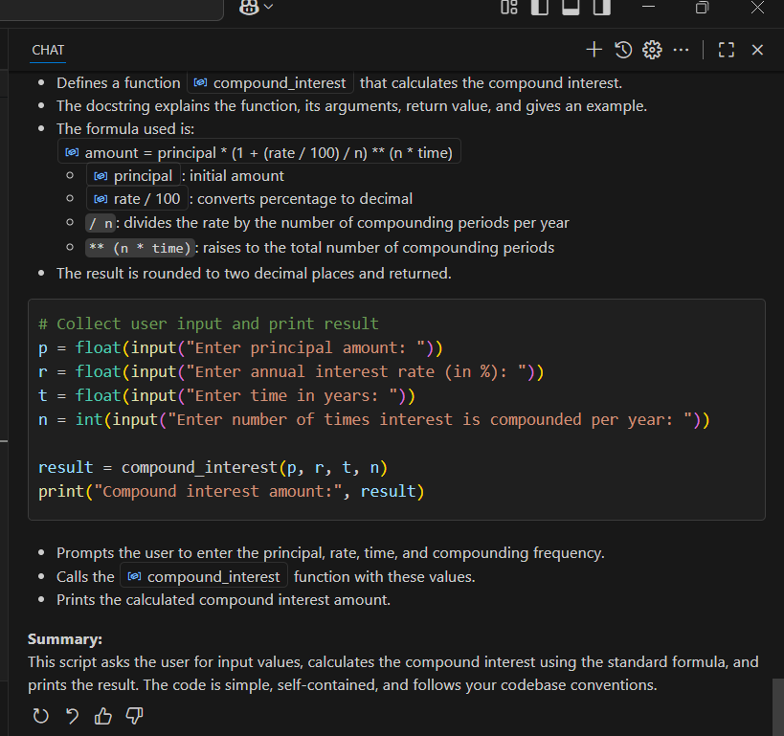
3.2:
PROMPT: Do math stuff, then refine it to: # Write a function to calculate average, median, and mode of a list of numbers.
Expected Output#2
- AI-generated function evolves from unclear to accurate multi-statistical operation.
CODE:
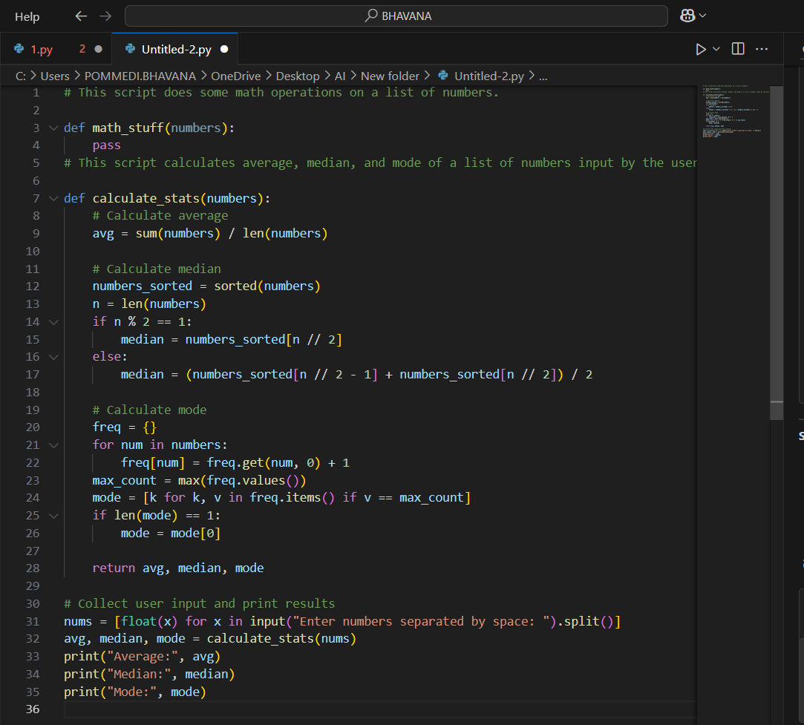
OUTPUT:
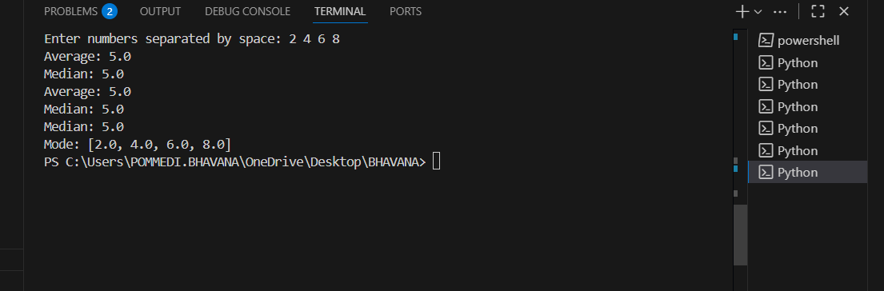
EXPLANATION:
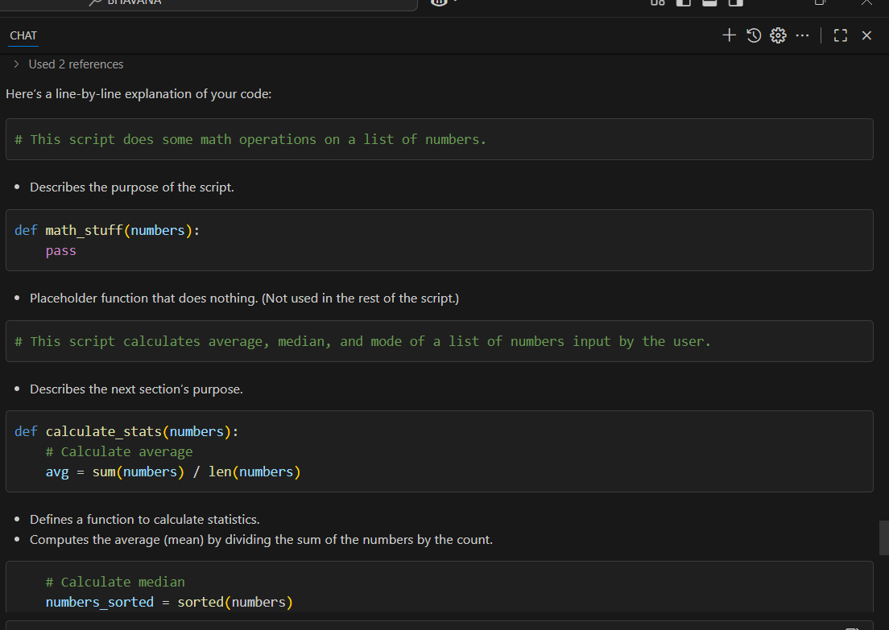
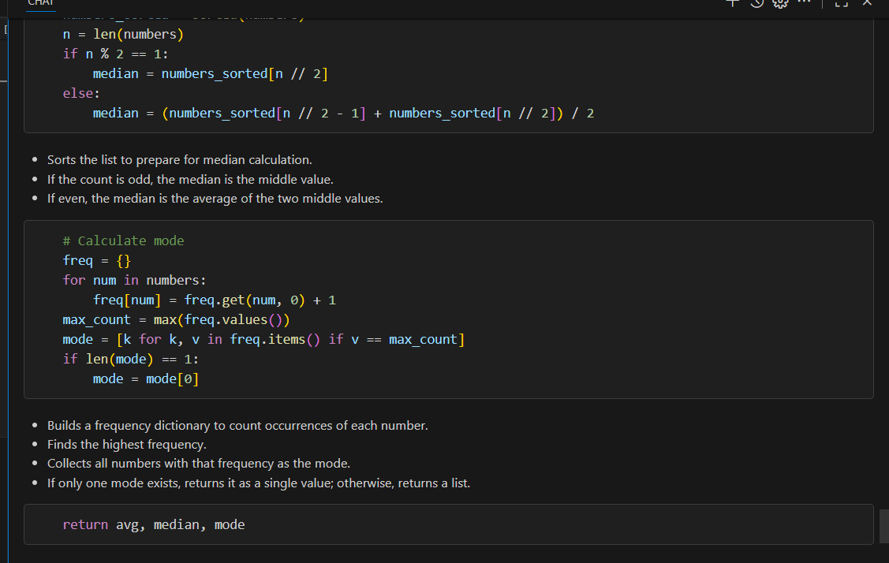
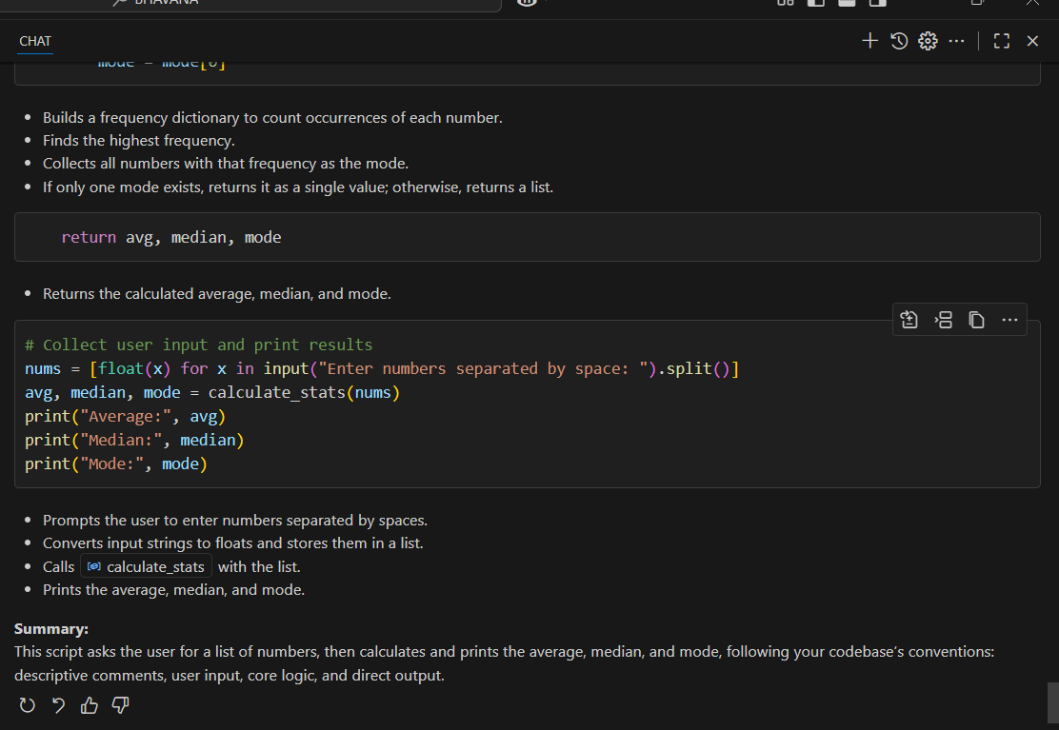
3.3:
PROMPT: Provide multiple examples of input-output to the AI for convert_to_binary(num) function. Observe how AI uses few-shot prompting to generalize.
Expected Output#3
- Enhanced AI output with clearer prompts
CODE:
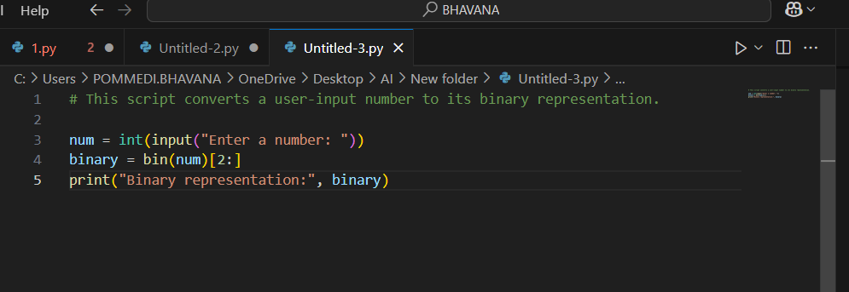
OUTPUT:
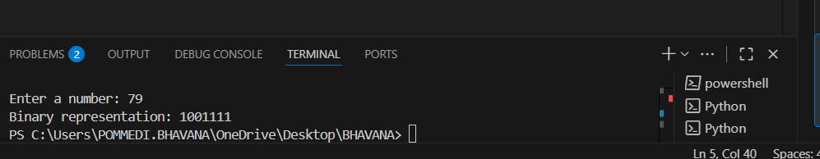
EXPLANATION:
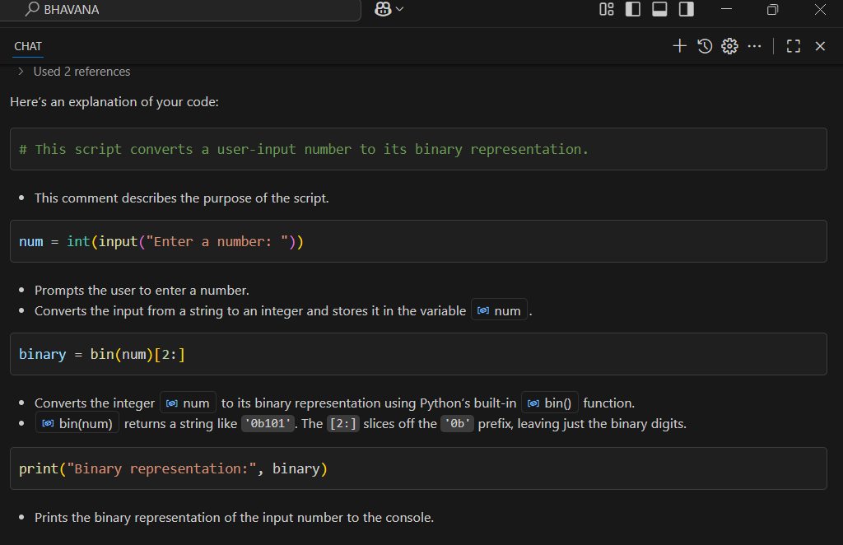
3.4:
PROMPT:Create an user interface for an hotel to generate bill based on customer requirements
Expected Output#4
- Consistent functions with shared logic
CODE:
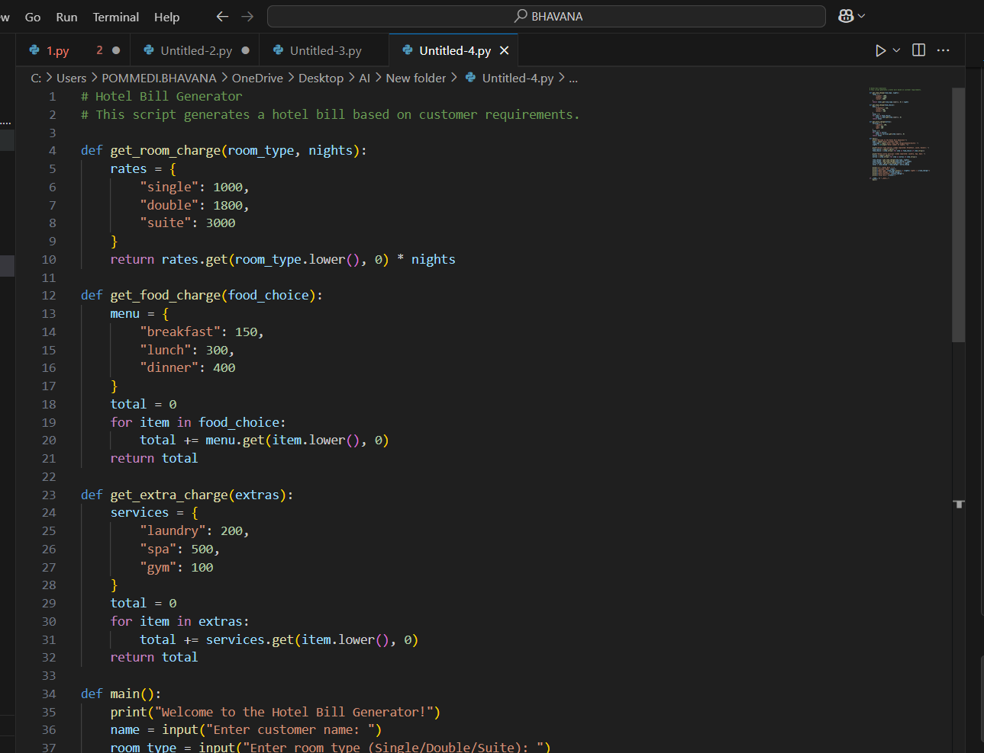
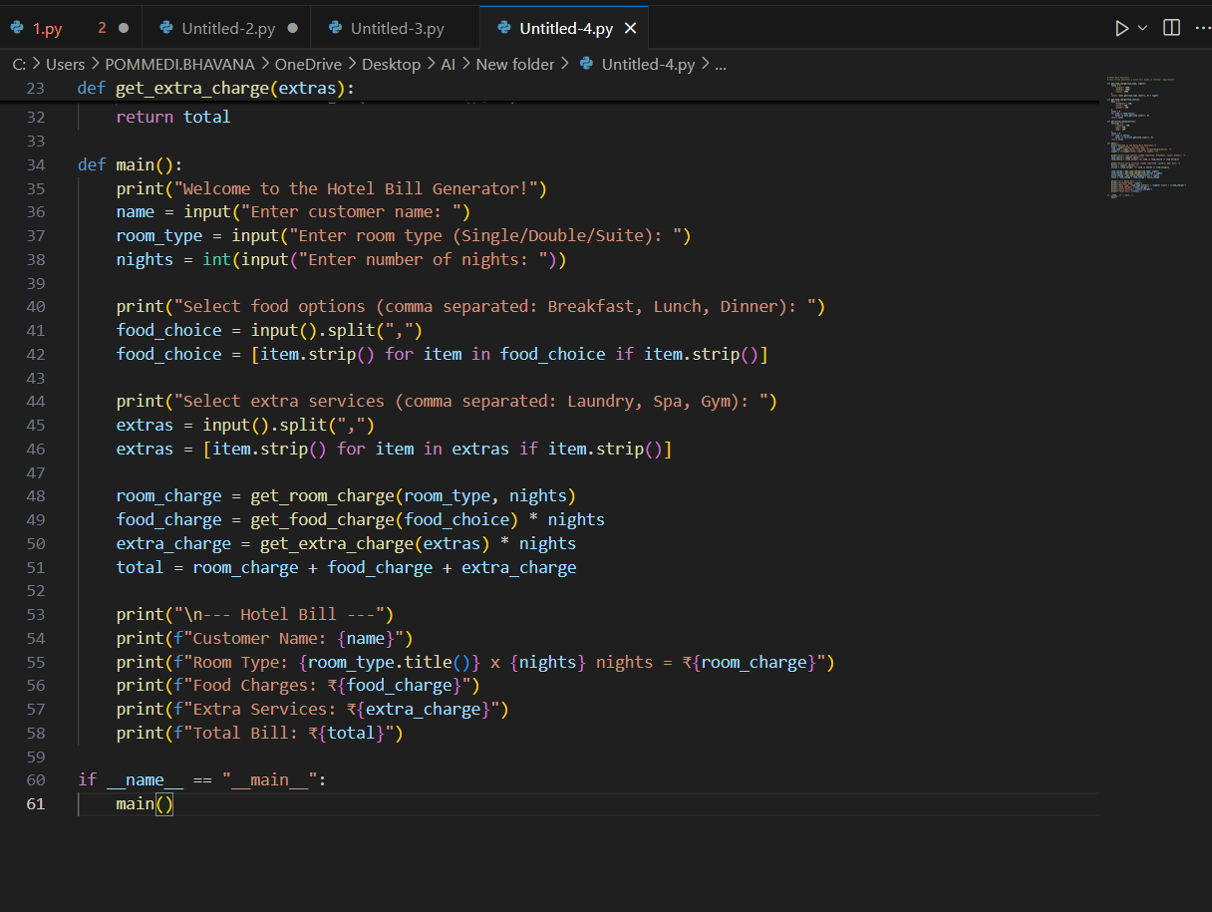
OUTPUT:
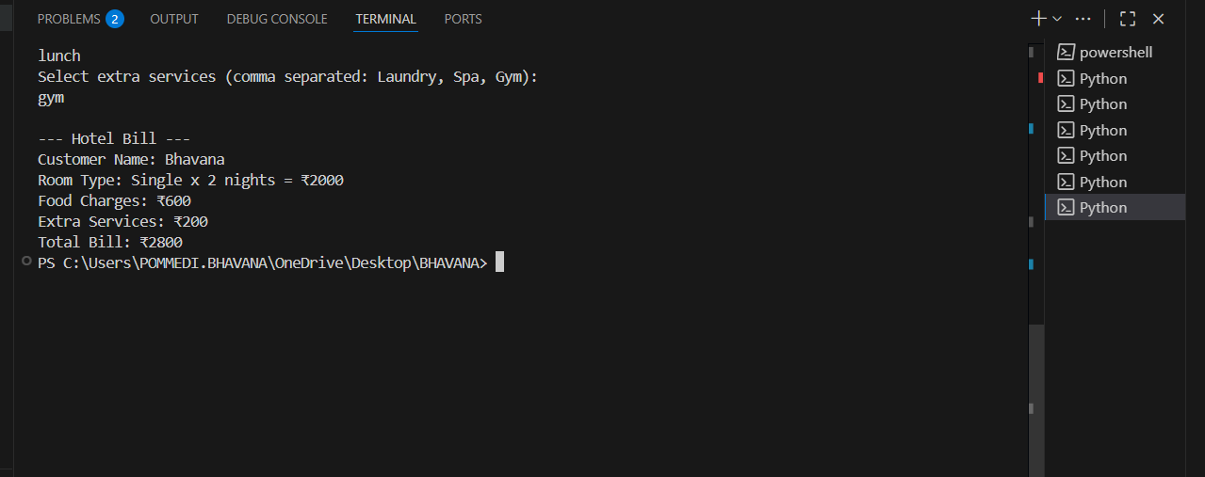
EXPLANATION:
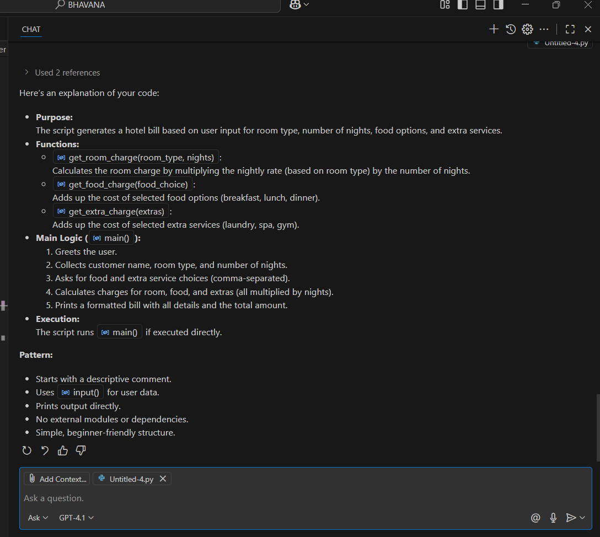

3.5:
PROMPT: Analyzing Prompt Specificity: Improving Temperature Conversion Function with Clear Instructions
Expected Output#5
- Code quality difference analysis for various prompts

CODE:
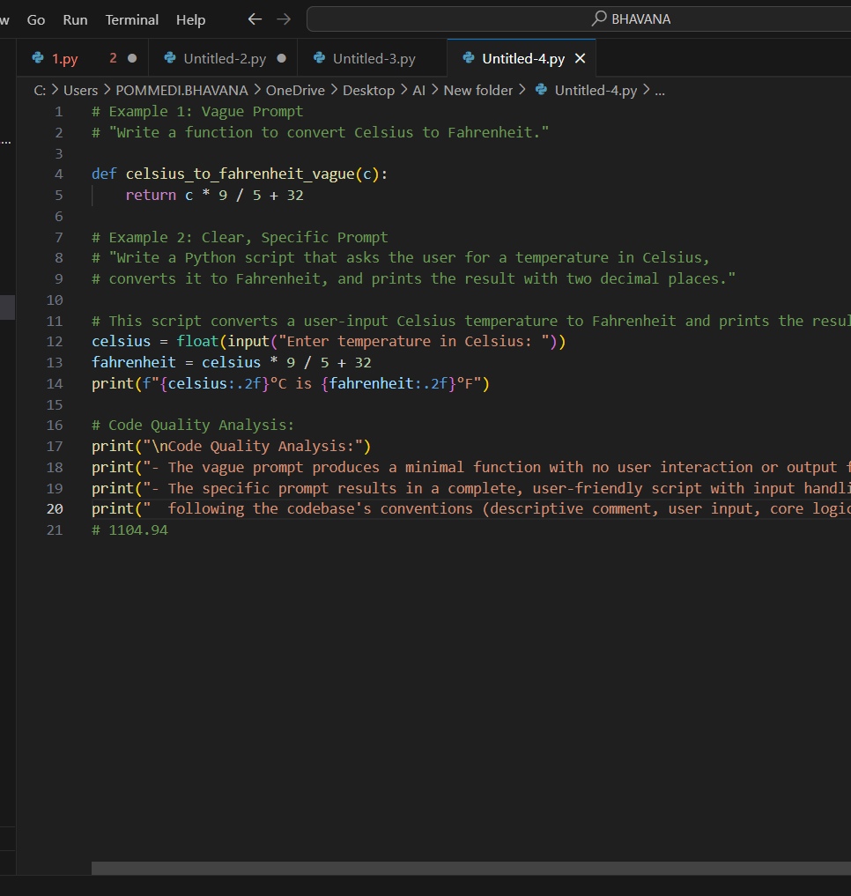

OUTPUT:
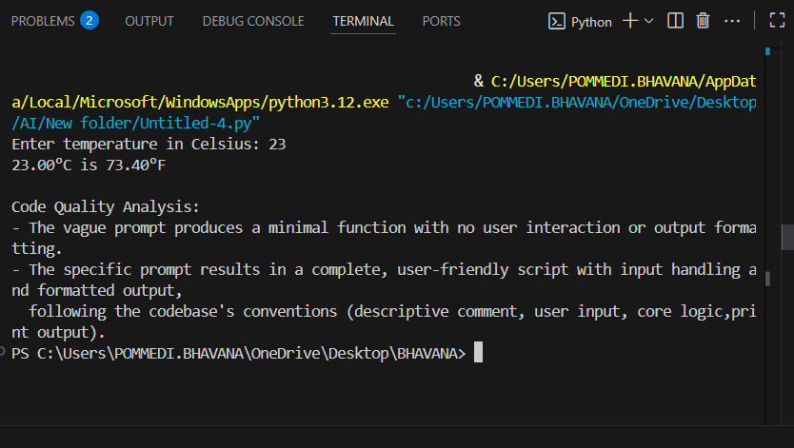

EXPLANATION:
